

**Mathematics Specialist**

**Unit 3**

**2017**

**TEST 4:**

**Differentiation and Integration**

**Student name:** _______________________  **Teacher name:** _______________________

**Time allowed for this task: *50 minutes***, in class, under test conditions

**Materials required:**

Standard items: Pens (blue/black preferred), pencils (including coloured), sharpener, correction fluid/tape, eraser, ruler, highlighters, SCSA Formula Sheet.

Classpad Calculator and Scientific Calculator.

Special items: Drawing instruments, templates

**Calculator Free: 24 *marks***

***Time: 25 minutes***

**Calculator Assumed: 22 marks**

***Time:* *25* *minutes***

**Task weighting: 8%**

Calculator Free

Question 1 (6 marks)

Determine for each of the following:

1. (3 marks)

(b) and simplifying in terms of (3 marks)

Question 2 (7 marks)

Evaluate exactly:

(a) ) (4 marks)

(b) (3 marks)

Question 3 (4 marks)

Use the substitution 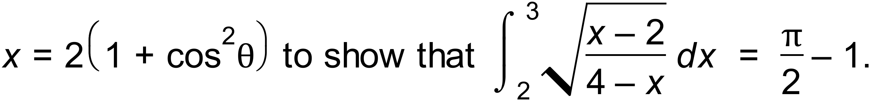

Question 4 (3 marks)

Find the equation of the tangent to the curve  at the point (1, -2).

**Question 5 (4 marks)**

Using partial fractions, or otherwise, determine .

Calculator Assumed

**Question 6**  **(7 marks**)

The graph of is shown below, where and A is the smallest root of .

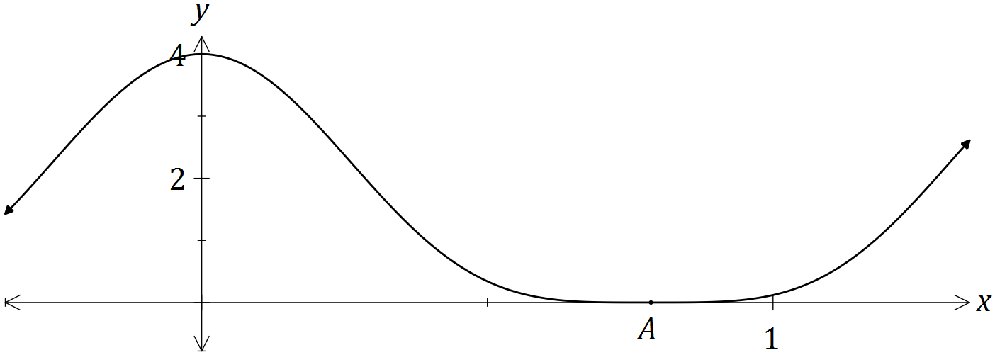

(a) Show that . (3 marks)

(b) Hence determine . (2 marks)

(c) Determine the exact volume of the solid generated when the region bounded by , and is rotated through 360° about the x-axis. (2marks)

Question 7 (5 marks)

A four metre long water tank, open at the top, is in the shape of a triangular prism. The triangular face is a right isosceles triangle with congruent sides of one metre length.

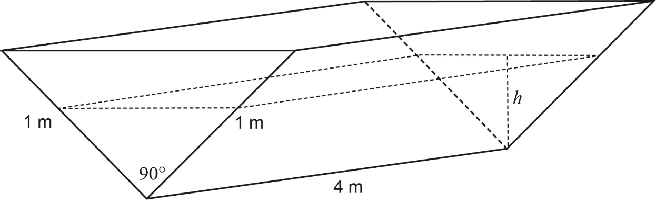

Initially the tank is completely full with water, but it develops a leak and loses water at a constant rate of 0.08 cubic metres per hour.

Let *h =* the depth of water, in metres, in the tank after *t* hours.

(a) Show that the volume of water in the tank *V* cubic metres, is given by the expression

(2 marks)

(b) Determine the rate of change of the depth, correct to the nearest 0.01 metres per hour,

when the depth is 0.6 metres. (3 marks)

Question 8 (10 marks)

The Volume *V* of blood flowing through an artery in unit time can be modelled by the formula

, where is the radius of the artery and is a constant.

(a) What is the effect of the volume of blood flow if the radius of the artery is halved? (2 marks)

(b) Use the incremental formula to estimate the percentage decrease in the radius of a partially clogged artery that will produce a 10% decrease in the flow of blood. (5 marks)

(c) Show that the incremental formula gives a physically absurd estimate of the change in resulting from a halving of the radius of the artery. Explain why this estimate is so poor compared to the true answer found in (a). (3 marks)